## Day 5: DID Analysis

Learn how to conduct DID Analysis in STATA

1. **Basic Idea**

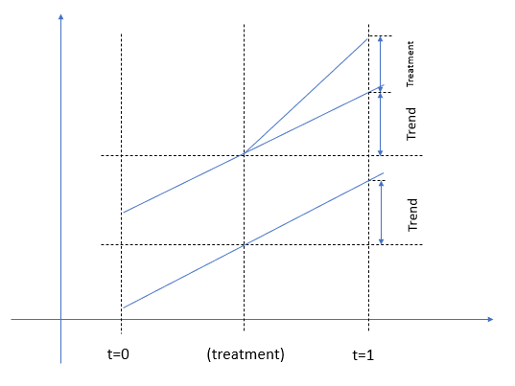

Two time periods ($t=\{0,1\}$), two groups (treatment group and control group).

Parallel trend assumption: the outcomes of both groups would have followed the same trend over time if treatment were not in place.

----------------------------------------------------

webuse hospdd

Several hospitals are using a new procedure for registration, we would like to see if the new procedure affects patients’ outcomes, measured by *satis*.

didregress (satis) (procedure), group(hospital) time(month)

-----*The model specifications should be enclosed in parentheses*

estat trendplots

estat ptrend

-----*Cannot reject null hypothesis, therefore parallel trend is satisfied*

estat granger

-----*‘Placebo’ test, cannot reject null hypothesis, therefore the effects exists*

*OR*

reghdfe satis procedure, absorb(hospital month)

-------------------------------------------------------

1. **Two-way fixed static DID model**

Beck et.al (2010), Big bad banks? The winners and losers from bank deregulation in the United States. *The Journal of Finance*, 65(5): 1637-1667.

$$Y_{st}=α+βD_{st}+δX_{st}+Α_{s}+Β_{t}+ε_{st}$$

$D_{st}$ is a dummy variable of our interest, $D_{st}$ in equals one in the years after unit *s* is treated.

Fixed effects: $Α_{s}$ and $Β_{t}$

--------------------------------

replace procedure=0 if hospital<6 & month==4

----- *Assume hospitals from 1 to 5 are treated in May rather than April*

didregress (satis) (procedure), group(hospital) time(month)

----- *However, the pre-trend plot function are no longer optional*

reghdfe satis procedure, absorb(hospital month)

1. **Event study DID model**

Model from my own paper:

With multiple treatment timing, we would like to know how treatment effects vary across time with an event study model.

-----*The canonical DID model might be biased in multiple time treatment settings. Event study model might also be biased but that’s another story.*

The basic idea is to compare the outcomes with base time ( $t=-1$ here).

--------------------------------

webuse hospdd, clear

replace procedure=0 if hospital<10 & month==4

replace procedure=0 if hospital>5 &hospital<10 &month==5

----*Same as above, we load the data again, hospitals 1 to 5 are treated in May, hospitals 6 to 9 are treated in June, hospitals 10 to 18 are treated in April.*

gen a=month if procedure==1

bysort hospital: egen t_month=min(a)

-----*We generate a variable describing when a hospital is treated.*

gen rel_month=month-t_month

forvalues i=1/4{

gen post`i’=1 if rel_month==`i’

replace post`i’=0 if missing(post`i’)

}

forvalues i=1/7{

gen pre`i’=1 if rel_month==`i’

replace pre`i’=0 if missing(pre`i’)

}

gen current=1 if rel_month==0

replace current=0 if missing(current)

-----*Creating the D variables in the model*

(replace post7=1 if rel_month>7)

(replace pre4=1 if rel_month)

reghdfe satis pre7 pre6 pre5 pre4 pre3 pre2 current post1 post2 post3 post4, absorb(hospital month)

-----*As baseline, pre1 is not included here*

coefplot, baselevels keep(pre5 pre4 pre3 pre2 pre1 current post1 post2 post3) vertical coeflabels(pre5 = "-5" pre4 = "-4" pre3 = "-3" pre2 = "-2" current = "0" post1 = "1" post2 = "2" post3 = "3") yline(0) ylabel(-1(0.1)1) xline(4.5, lwidth(vthin) lpattern(dash) lcolor(teal)) ylabel(,labsize(*0.75)) xlabel(,labsize(*0.75)) ytitle("Dynamic Effect", size(small)) xtitle("Rel_month", size(small)) addplot(line @b @at) ciopts(lpattern(dash) recast(rcap) msize(medium)) msymbol(circle_hollow) scheme(s1mono)

---------------------